9.1.2 Palindrome or not
ALGORITHM
1.Start
2.Read string X
3.Find reverse of X and store in variable reverse
4.Compare X with reverse
5.If X is equal to reverse, print "Palindrome"
6.Else, print "Not a Palindrome"
7.Stop
Flowchart
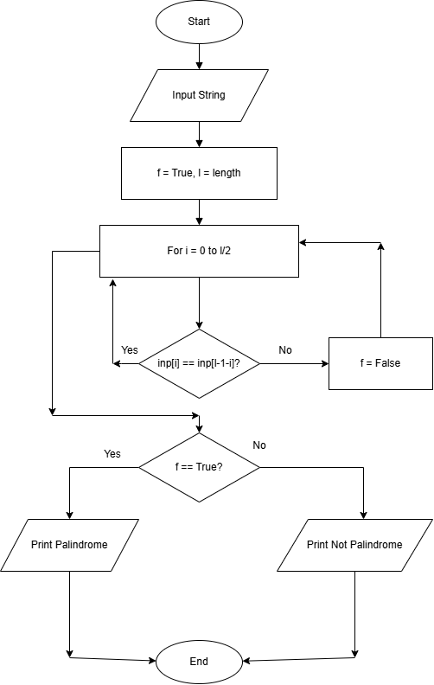

Python code
inp = input()
f = True
l = len(inp)
for i in range(1):
if inp[i]!= inp[l - 1 -i]:
f=False
if f:
print("Palindrome")
else:
print("Not a Palindrome")
Excecution
